Colourful Flowers

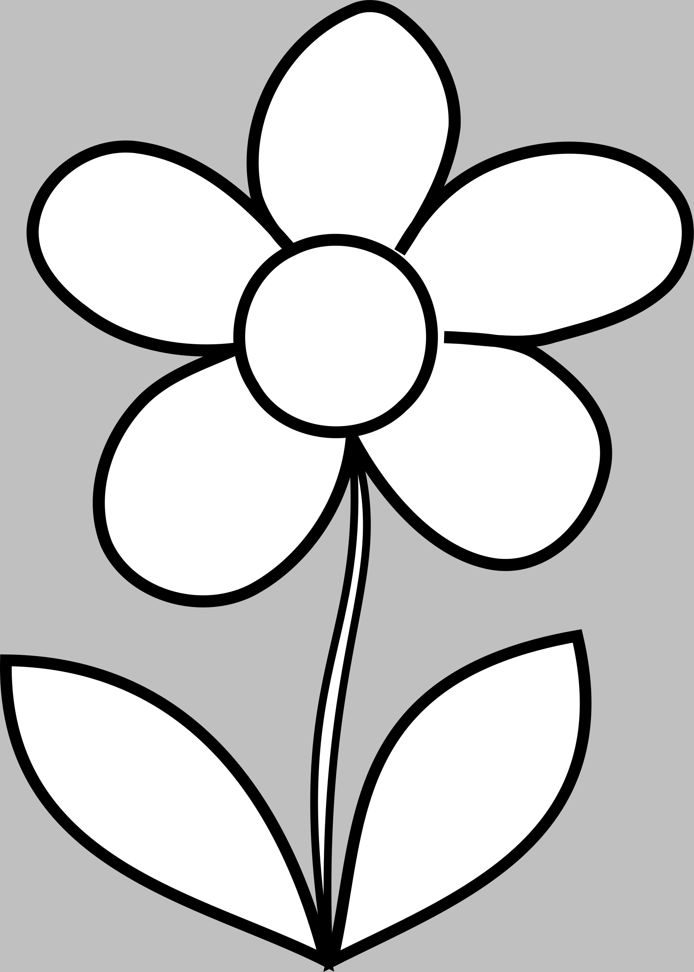

**Brown**



**Yellow**



**Purple**



**Orange**



**Pink**



**Blue**



**Green**



**Red**