Continents of the world worksheet
Look at the map of the world below. Write the names of each continent according to the numbers.

(clues: Asia, Africa, North America, South America Antarctica, Europe, Australia)
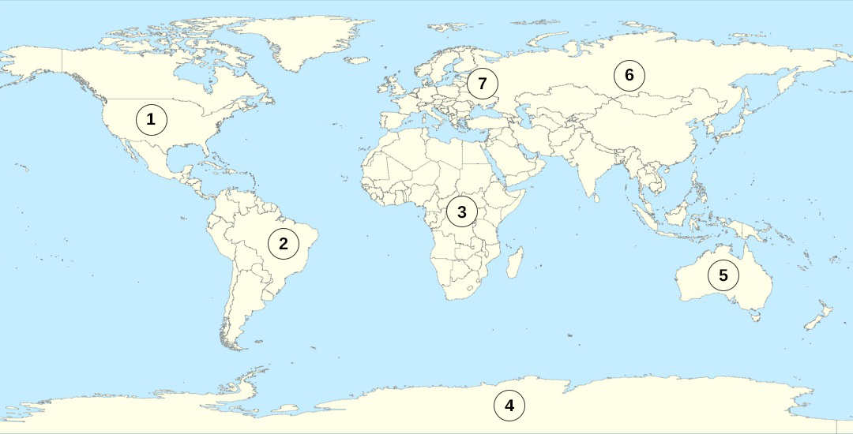

1 ________________________________________
2 ________________________________________
3 ________________________________________
4 ________________________________________
5 ________________________________________
6 ________________________________________
7 ________________________________________

