States of United States of America worksheet

Look at the map of the United States of America below. Write the names of each States according to the numbers.
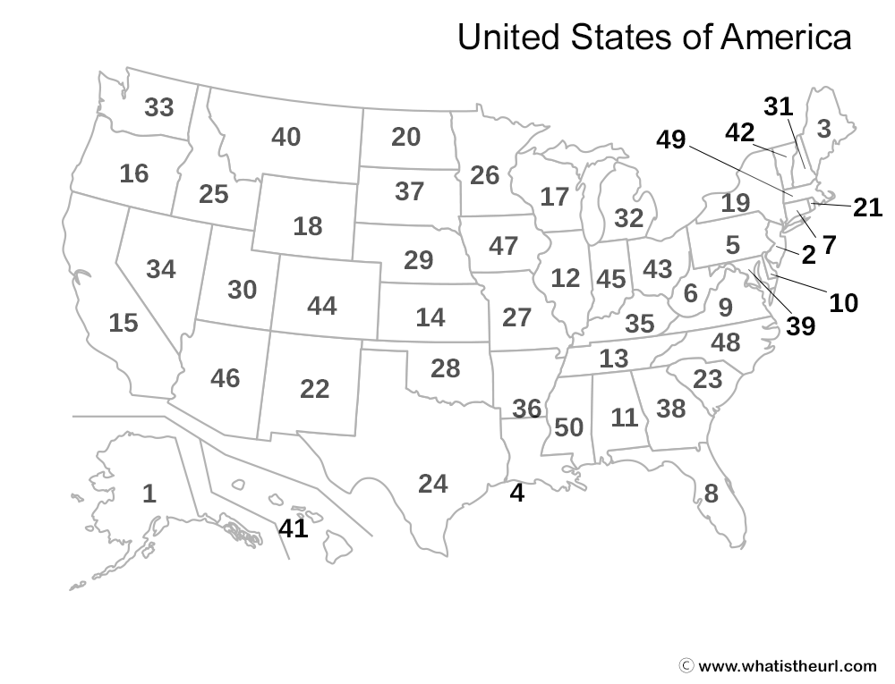
1 __________________________ 2 __________________________
3 __________________________ 4 __________________________
5 __________________________ 6 __________________________
7 __________________________ 8 __________________________
9 __________________________ 10 __________________________
11 __________________________ 12 __________________________
13 __________________________ 14__________________________
15 __________________________ 16 __________________________
17 __________________________ 18 __________________________
19 __________________________ 20 __________________________
21 __________________________ 22 __________________________
23 __________________________ 24 __________________________
25 __________________________ 26 __________________________
27 __________________________ 28 __________________________
29 __________________________ 30 __________________________ 31 __________________________ 32 __________________________
33 __________________________ 34 __________________________
35 __________________________ 36 __________________________
37 __________________________ 38 __________________________
39 __________________________ 40 __________________________
41 __________________________ 42 __________________________
43 __________________________ 44 __________________________
45 __________________________ 46 __________________________
47 __________________________ 48 __________________________
49 __________________________ 50 __________________________

(clues: Alabama, Alaska, Arizona, Arkansas, California, Colorado, Connecticut, Delaware, Florida, Georgia, Hawaii, Idaho, Illinois, Indiana, Iowa, Kansas, Kentucky, Louisiana, Maine, Maryland, Massachusetts, Michigan, Minnesota, Mississippi, Missouri, Montana Nebraska, Nevada, New Hampshire, New Jersey, New Mexico, New York, North Carolina, North Dakota, Ohio, Oklahoma, Oregon, Pennsylvania, Rhode Island, South Carolina, South Dakota, Tennessee, Texas, Utah, Vermont, Virginia, Washington, West Virginia, Wisconsin, Wyoming)

